# PROJECT REP0RT

1.INTRODUCTION

1.1Overview

A market analysis does not only reveal the past and current state of a market, but also the trend of its future development. For this purpose, the potential analysis highlights potential employees, market entry barriers, success factors, as well as current developments and trends.

1.2 Purpose

A market analysis provides information about industries, customers, competitors, and other market variables. You can also determine the relationship between supply and demand for a specific product or service. Based on these insights, you can make more informed decisions about possible marketing strategies.

2. PROJECT DEFINITION AND DESIGN THINKING

2.1 Empathy map

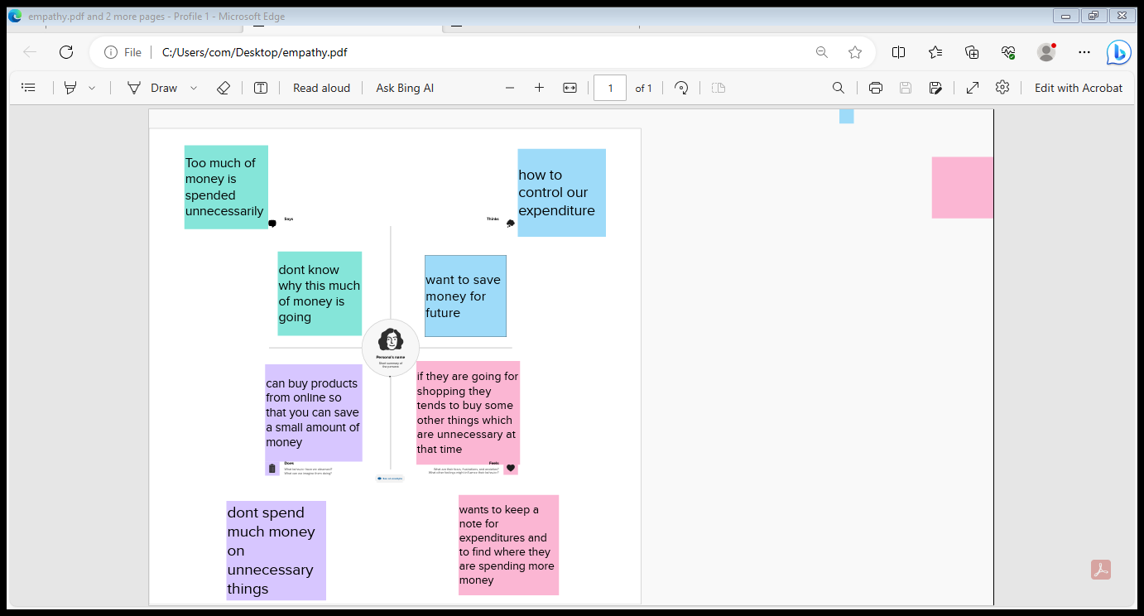

2.2 Ideation and brainstorming map

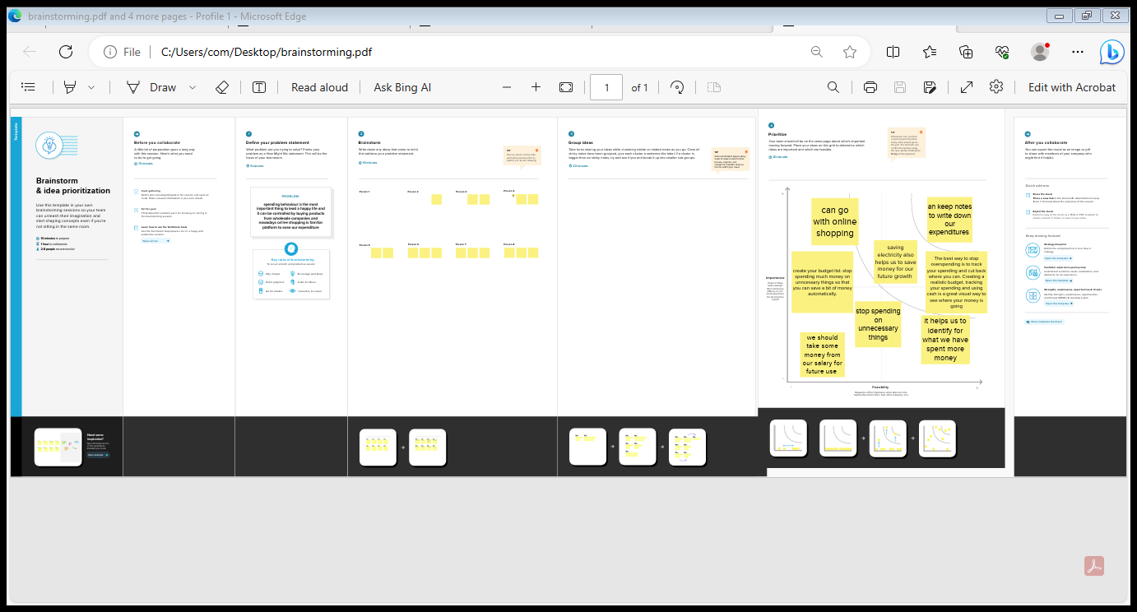

3.RESULT

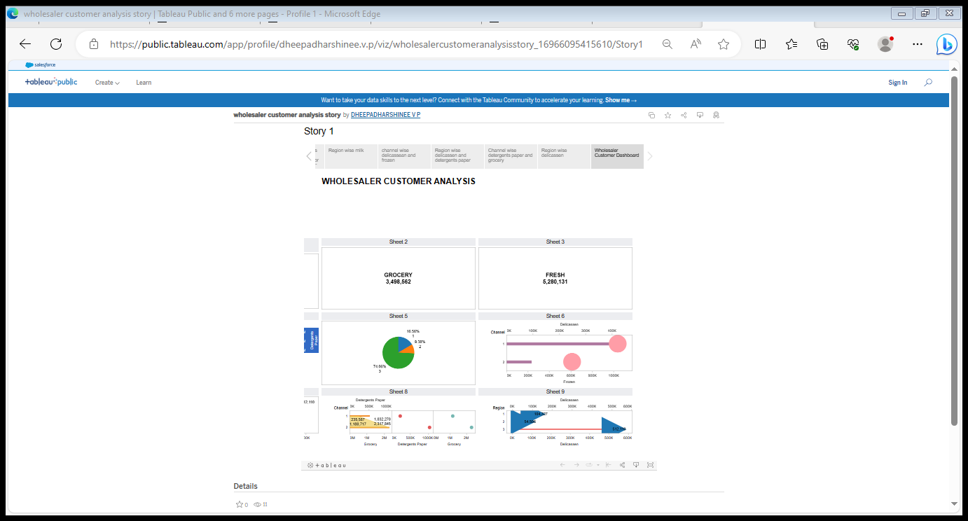

4.ADVANTAGES AND DISADVANTAGES

4.1 Advantages

* A wholesaler is a person or company who sells products in bulk to various outlets or retailers for onward sale, either directly or through a middleman.
* Wholesalers are able to sell their products for a lower price as they are selling in bulk, which reduces the handling time and costs involved.
* Conducting a market analysis can benefit you in several ways by helping you to: Spot trends and opportunities in your industry.

4.2Disadvantages

* One of the most common issues in marketing analytics is a surplus of incoming data.
* This forces you to spend a lot of time and effort to identify which information is most relevant.
* More data means more time to sort, so there might be delays in results.

5.APPLICATIONS

* Market analysis is a detailed assessment of your business's target market and the competitive landscape within a specific industry.
* This analysis lets you project the success you can expect when you introduce your brand and its products to consumers within the market.
* Businesses can use market analysis to prepare their business plans and gain a deeper understanding of the market size, potential audience, profitability, and growth rate.
* The analysis enables businesses to make informed decisions, identify opportunities, and develop strategies to achieve their goals and objectives.

6.CONCLUSION

* As a conclusion, the marketing concept is the philosophy where each and every firms should analyze the needs of their customers and makes good decisions in order to satisfy their needs.
* This also can enhance a good relationship between the customers.

7.FUTURE SCOPE

* It encompasses market research, product development, pricing, advertising, sales, and customer service.
* The scope of marketing also extends to the management of relationships with customers, suppliers, and other stakeholders, as well as the development of marketing strategies and plans.